Brochure Title | 
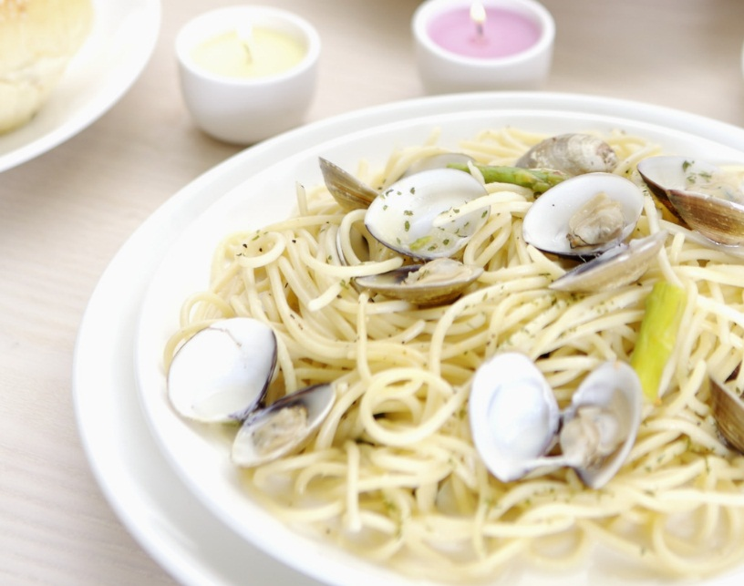 | 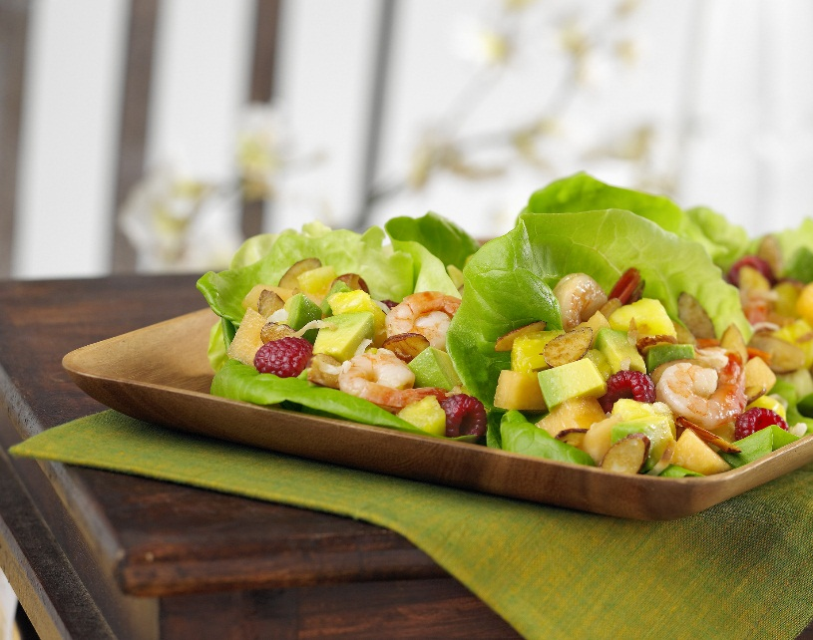

  - Subtitle
To get started right away, just tap any placeholder text (such as this) and start typing to replace it with your own.

Heading 1


Heading 2
View and edit this document in Word on your computer, tablet, or phone. You can edit text; easily insert content such as pictures, shapes, and tables; and seamlessly save the document to the cloud from Word on your Windows, Mac, Android, or iOS device.


Heading 2
Want to insert a picture from your files or add a shape, text box, or table? You got it! On the Insert tab of the ribbon, just tap the option you need.


Heading 2
To apply any text formatting you see on this page with just a tap, on the Home tab of the ribbon, check out Styles.

